





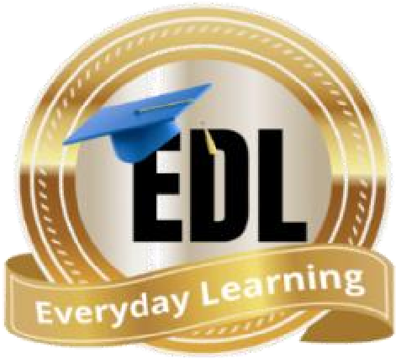

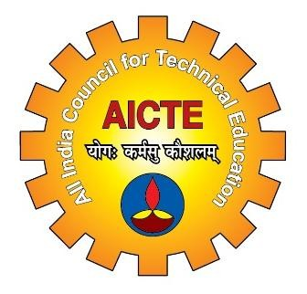
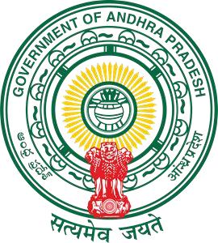

Certificate of
Comple
tion

This is to certify

that

Doolla Tharunsai

-

Electronics And Communication Engineering

-

23X55A0407

of

Santhiram Engineering college, Nandyal

has successfully

completed

Long
-
Term Internship

on

VLSI

Organized by ExcelR Edtech Pvt. Ltd. in collaboration with

Andhra Pradesh State Council of Higher Education

From
21

November 20
25

to

28
March
2026

Certificate
No: EXCELR
-
I
-

79165

No. of Credits: 6

Presented on
30

March 2026

ANDHRA PRADESH STATE COUNCIL OF HIGHER EDUCATION

A Statutory Body of Government of A.P.
(
)

Ram Tavva

CEO,
ExcelR EdTech Pvt. Ltd.

